PRACTICAL-4

**SETTING UP AND CONFIGURATION OF XAMPP SERVER**

**PROCEDURE:**

1. Download XAMPP Server.
2. Open XAMPP Control Panel.

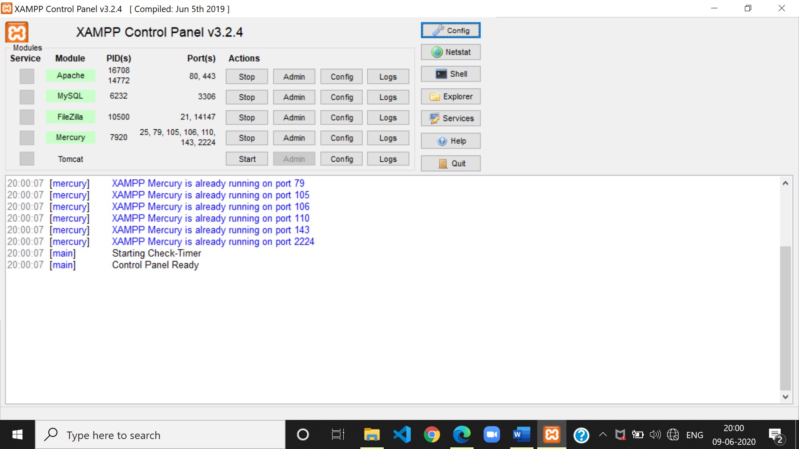

1. Switch on Start to start the servers.

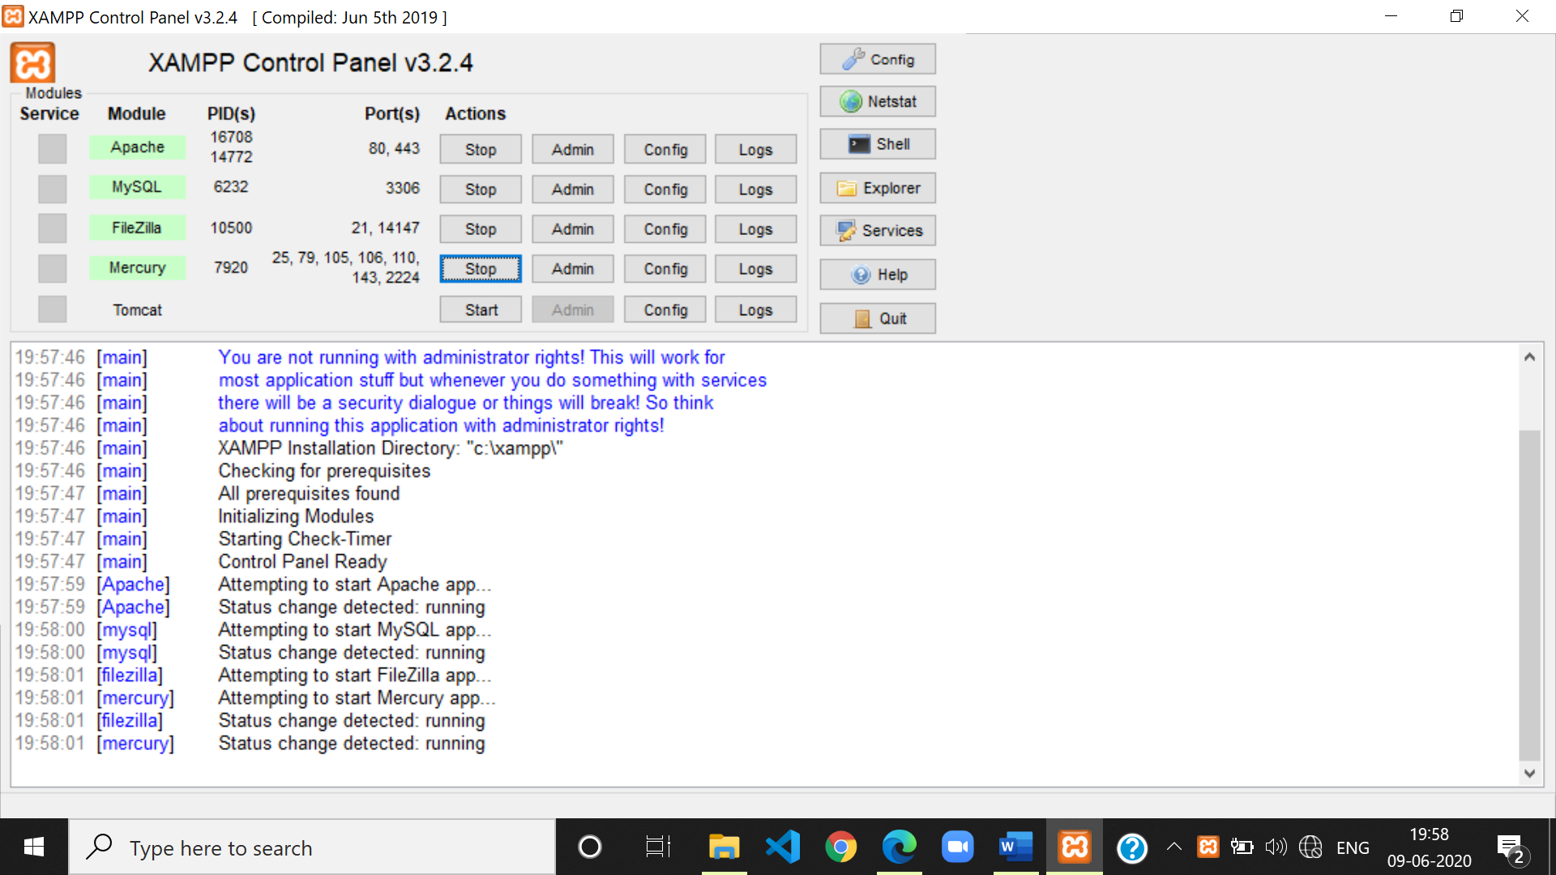

1. XAMPP localhost server is being set up now. Open localhost in any web browser.

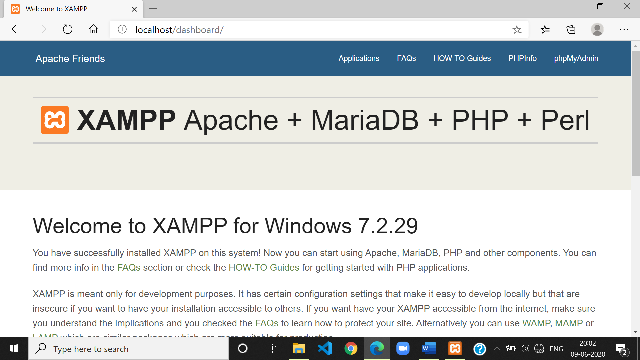

1. Open XAMPP directory in the localhost and run your code.

